2022-2023 Course Recommendation Form

*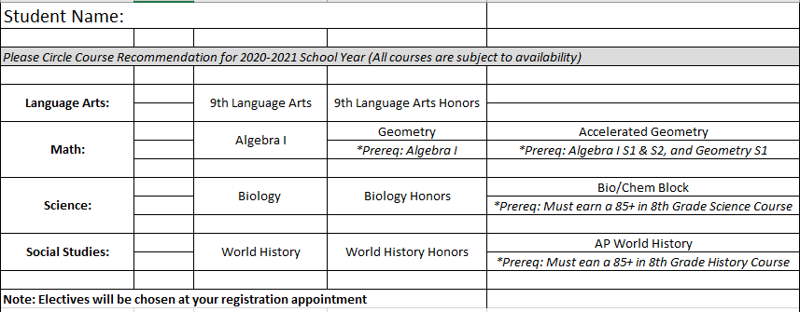To be completed by 8th grade core content teachers*